**Train Tracking and Arrival Time Prediction App - SRS Document**

**1. Scope**

The Train Tracking and Arrival Time Prediction app is a mobile application designed to provide real-time information about train locations, schedules, and predicted arrival times to passengers and commuters. This app aims to enhance the travel experience for train users by offering accurate and up-to-date information.

**2. General Description**

a. Target Audience

- People who rely on trains for daily transportation.

- Tourists and occasional train travelers.

- Train station personnel and staff.

b. Objectives

- Provide real-time train tracking information.

- Predict train arrival times based on historical and live data.

- Offer a user-friendly interface for easy access to train schedules.

c. Constraints

- Availability of accurate real-time train data.

- Dependence on the quality and reliability of GPS and network connections for location tracking.

- Compatibility with various mobile platforms (iOS and Android).

**3. Functional Requirements**

1. User Registration and Authentication:

- Users can create accounts with their personal information.

- Users can log in securely.

2. Train Tracking:

- Display a list of available train routes.

- Allow users to select a specific train for tracking.

- Show the real-time location of the selected train on a map.

- Provide details about the train's current speed, stops, and delays if any.

3. Arrival Time Prediction:

- Predict the estimated arrival time of the selected train at a user-defined station.

- Take into consideration historical data and real-time conditions to improve accuracy.

4. Train Schedule:

- Display train schedules for different routes.

- Allow users to search for specific trains and view their schedules.

5. Notifications:

- Send notifications to users about delays, cancellations.

**4. Non-Functional Requirements**

- Performance: The app should respond quickly to user interactions and provide real-time data updates.

- Security: Ensure the security of user data and privacy.

- Usability: The app should have a user-friendly interface.

- Reliability: Dependable access to real-time train data.

- Compatibility: Support for both iOS and Android platforms.

**5. Use Case Models (Diagrams using UML)**

- Use Case Diagram:

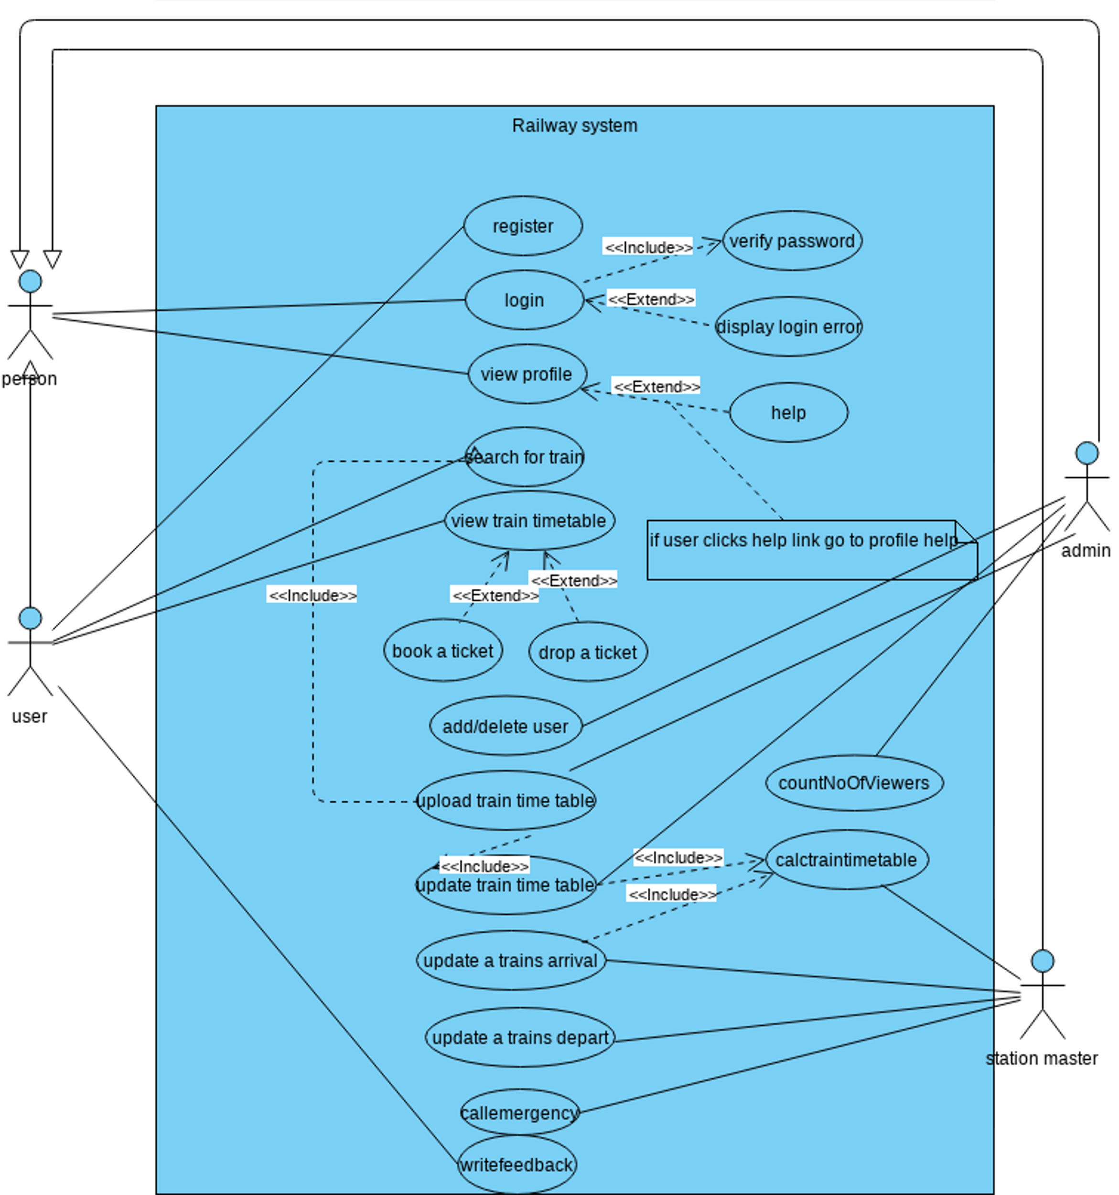

**6. Appendices**

a. Definitions, Acronyms, Abbreviations

- GPS: Global Positioning System

- API: Application Programming Interface

b. References

<https://online.visual-paradigm.com/community/share/a-railway-tracking-and-arrival-time-prediction-applica-xe12r71u1> (for UML diagram)